8.1.1 Editors - Image Editor - Header - View menu
Image Editor - View Menu 2
Toolbar 2
Sidebar 2
Tool Settings 2
Adjust Last Operation 2
View Zoom In 2
View Zoom Out 2
Zoom to Border 3
Fractional Zoom 3
View All 3
View Fit 3
Center View to Cursor 3
Area 3
Horizontal Split 3
Vertical Split 3
Duplicate Area into New Window 3
Toggle Maximize Area 3
Toggle Full screen Area 4

Image Editor - View Menu

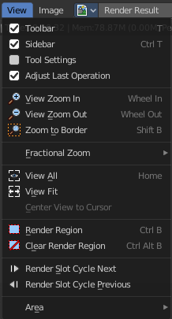
The View menu contains all View related tools.
It is available in all sub modes.

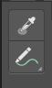
Toolbar
Shows or hides the toolbar at the left.

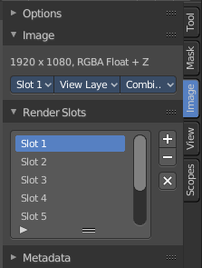
Sidebar
Shows or hides the sidebar at the right in the 3D view.

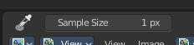
Tool Settings
Shows or hides the tool settings above the header in the 3D view.

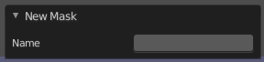
Adjust Last Operation
Shows or hides the Adjust Last Operation panel down left.

Note that the Adjust Last Operation menu item in the Edit menu in the main header and the Last button in the toolbar are not related and not functional with this last operator panel. It is an independant element.

View Zoom In
Zooms into the viewport.

View Zoom Out
Zooms out of the viewport.

Zoom to Border
Draws a rectangle and zooms then to fit the size of this rectangle.
Zooming in is done with drawing the rectangle with left mouse button. Zooming out is done with drawing the rectangle with middle mouse button.

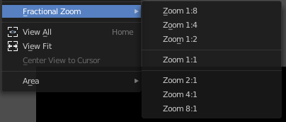
Fractional Zoom
A sub menu where you can choose between predefined zoom factors.

View All
View all zooms in or out in the viewport until all objects in the scene are displayed fitting in the viewport.

View Fit
Zooms out or in to fit the image to the viewport.

Center View to Cursor
Mask Mode only. Centers the view to the 2D cursor.


Area
This menu contains general view functionality. And exists in most other editor types too.

Horizontal Split
Splits the current view horizontally into two independant editor windows.

Vertical Split
Splits the current view vertically into two independant editor windows.


Duplicate Area into New Window
Duplicate Area into New Window makes the selected editor window floating. You can then drag it around at the monitor. It is not connected with the rest of the UI anymore.
A separated window cannot be merged into the main window again. You have to close it when not longer needed.

Toggle Maximize Area
Displays the editor maximized with menus.
To return from the maximized view press hotkey ctrl + spacebar. Or reuse the menu item in the area menu.

Toggle Full screen Area
Displays the editor maximized without menus.
To return from the full screen view press hotkey ctrl + alt + spacebar.

